Villa Modiani
Locality Pisa area
6 double bedrooms
4 twin/double bedroom
2 twin bedroom
Bathrooms
10/12 en-suite

5 km dal mare
Pets on request
Suitable for disabled

Description
Villa Modiani is a delightful villa with swimming pool in Tuscany for rent surrounded by a beautiful estate of olive trees. A charming avenue of cypress trees passes through the olive fields and leads guests up to the house.

Absolute privacy is guaranteed by coded access from the gate so only guests of the villa can enter the property.

This charming villa with pool in Tuscany for rent is divided into 3 units, two of them on the ground floor that have been joined and one on the second floor.
The main house has a total of 10 rooms with bathrooms for a total of 20 beds.
In addition, there is an annex that can accommodate additional people with two rooms with bathrooms
And a large kitchen suitable for groups of 20-24 people.
Convenient private parking in the immediate vicinity of the building.
Next to the annex is a laundry room with two washing machines and a dryer.

Both the main house and the annex are equipped with heating and air conditioning.

Details
North apartment: located in the northern part of the main building towards the pool, on the ground floor:
3 rooms with bathroom and possibly 4 being in connection with the south apartment and where the passage room can be attached to one or the other apartment therefore the capacity can be 6 or 8 people:
Double room with bathroom equipped with shower.
Twin or double room as needed and with corresponding bathroom equipped with shower.
Double room with bathroom equipped with shower.
4 bedroom: double room whose bathroom with shower and walk-in closet are located on a higher level and are reached by a staircase.
Large entrance into living room with table and TV, small kitchen equipped with 4-burner stove, dishwasher and refrigerator.
Exterior
a large shaded porch furnished with table and chairs.

South Apartment
This apartment is on two levels and can have 3 or 4 bedrooms for a total of 6 or 8 beds.
On the ground floor: entrance hall , living room, kitchen.
The kitchen, which is also accessed from the garden, is equipped with a 5-burner stove, large refrigerator, dishwasher, 60-cm electric oven
Ground floor rooms:
-double bedroom with bathroom equipped with shower also with entrance from the garden.
-twin or double room as needed and with corresponding bathroom equipped with shower. This room is on request in connection with the North Apartment .
Rooms on the second floor:
-double room with bathroom equipped with bathtub/shower.
-Double room whose bathroom with shower and walk-in closet are on a higher level and are reached by a staircase.
Exterior:
a large shaded porch furnished with table and chairs

Second floor apartment
Panoramic terrace furnished with table and chairs and has two shade awnings.

3 rooms with bathrooms for a total of 6 beds:
Double/Double with bathroom with shower
Double room with bathroom with shower and access to shared panoramic terrace.
Double/twin room and loft with single sofa bed and reading area. ( access to its bathroom with shower via a staircase ).

Kitchen equipped with 5-burner stove top, refrigerator, dishwasher, table with chairs and exits directly to the panoramic terrace equipped with table and chairs and two large shading awnings with manual opening.

DEPANDANCE
The dependance is independent
It has two entrances, one from the outside porch and one from the back also equipped with a slide suitable for wheelchairs.
Large kitchen and two rooms that also have direct entrance from the garden.
The two rooms are :
-double bedroom with bathroom
-double/double room. With bathroom suitable for people with disabilities.

The kitchen in the annex has two cooktops, one with 4 burners and one with 6 burners and a 90-cm oven.

Exterior:
The porch outside the annex is very large, equipped with table and chairs.
Laundry room with two washing machines and one dryer.

POOL
The pool measures 7 x 14 meters with a depth of 110 cm.
Entrance to the pool is by a convenient masonry staircase equipped with handrails.
The pool is fully fenced.

GARDEN
large BBQ with wood-burning oven

Equipment
Pets allowed
Bathroom suitable for disabled in annex
Air conditioning
American coffee
Espresso coffee
Refrigerator
Dishwasher
Washing machine
Microwave
Pool
Toaster
Wifi

Services included
Wifi
1 bebè bed is included in the price put prepared just upon customer request
GENERAL Consumptions
Linen and bath towels for 1 week

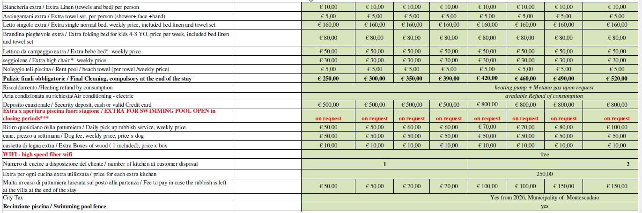
Extra costs

Goot to know
Security deposit, cash or valid Credit card**€ 800,00: A different amount could be asked in case of a long holiday or in other particular cases established by the property
Swimming pool fence
1 bebè bed is included in the price put prepared just upon customer request
CLEANING: the final period cleaning it is compulsory. In case of stays longer than 1 week the other cleanings are not compulsory but upon request.
WI-FI: the wifi is given through mobile devices.
The swimming pool is generally open from mid-May to the end of September. Size: 7 x 14 meters, 110 cm deep.
City tax: not included and to be paid at the end of the stay / please ask before the stay how is the amount of the local City tax.
Distances
1 hr 47 min (127.0 km) Florence
1 hr 11 min (94.0 km) Lucca
1 hr 41 min (90.6 km) Siena
1 hr 44 min (149.6 km) Montalcino
1 hr 20 min (67.4 km) San Gimignano
55 min (64.7 km) Pisa
3 hr 14 min (289.6 km) Roma
2 hr 5 min (171.2 km) Levanto ( le Cinque Terre)

About
The location is strategic, convenient and quiet, only 500 meters as the crow flies from the freeway exit and 5 km from the sea.

